CS 255 System Design Document
Trevor Powers

UML Diagrams

UML Use Case Diagram
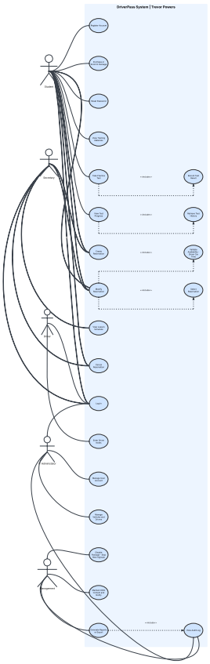
The use case diagram demonstrates how different users will interact with the DriverPass application. The primary actors include the Student, Instructor, Administrator, and the DMV system. The students will be able to create accounts, book driving lessons, take online practice tests, and access DMV training material. The instructors will be able to schedule lessons and record the results of lessons. The Administrators will be able to manage all users, refresh the content, and monitor performance. The DMV system will be able to provide the latest driving laws and educational material. This diagram ensures all major interactions are linked to the needs, as discussed in the DriverPass interview transcript.

UML Activity Diagrams

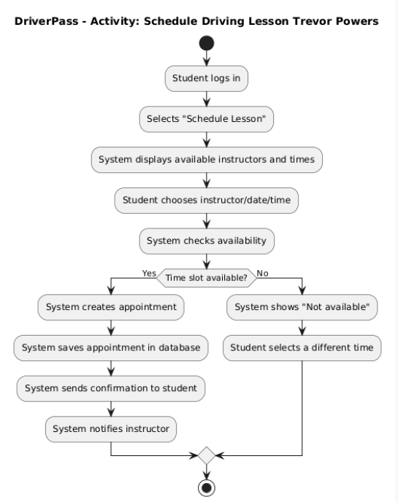
This activity diagram illustrates how a student schedules a driving lesson step by step. It begins with the students logging into their account and selecting the option for scheduling a lesson. The students can then see the available instructors and time slots based on the schedule. The student selects their chosen instructor and time slot. The system then checks whether the selected time slot is available. If it is available, the student’s appointment is created and saved, and a confirmation message is sent. If it is already taken, the student has the option to select a different time slot. This makes it easy and simple for users to schedule their lessons, which aligns with the needs identified by DriverPass.

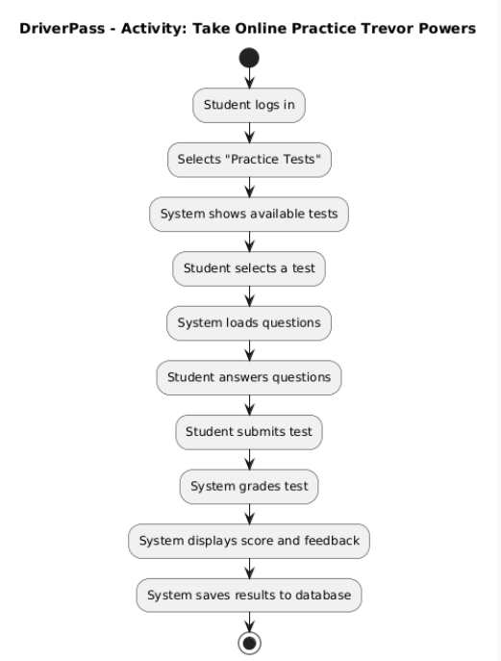
The activity diagram below illustrates how a student goes through the process of running through an online practice test using the DriverPass system. A student begins by logging in and then proceeding to select the practice test option from their dashboard. The system then retrieves the questions from its database and displays them to the student. After answering the questions, the student then submits them for grading. The system automatically grades the test and displays the results to the student for future reference. This feature is in line with DriverPass's main objective of assisting students in their preparations for the DMV written test.

UML Sequence Diagram
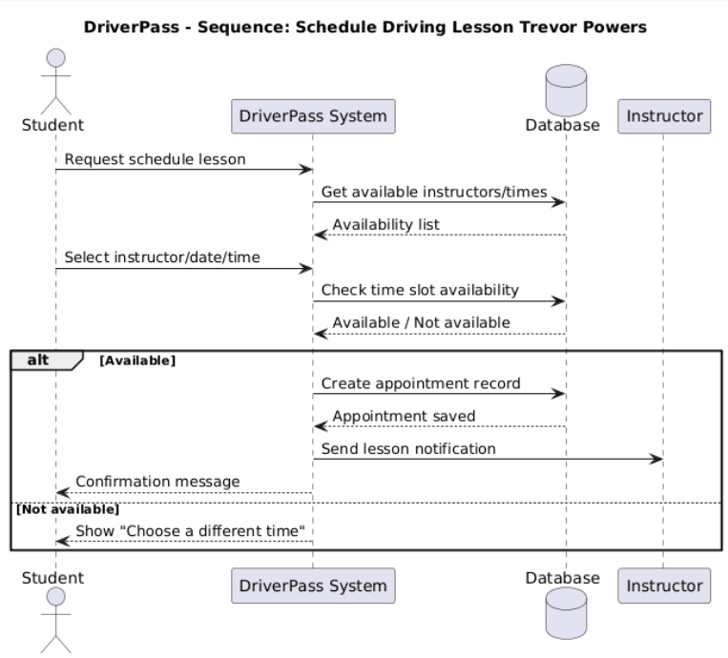

The diagram below illustrates how different components of the system communicate during the lesson scheduling. If a student wishes to schedule a lesson, the system checks the database to determine the availability of the instructors and time slots. Once the student has chosen the time, the system will then check the availability before scheduling the lesson. The lesson is then stored in the database, and both the student and instructor will be notified. This flow ensures that all lessons are scheduled correctly, avoiding conflicts, and all details regarding the lessons are stored in the system.

UML Class Diagram
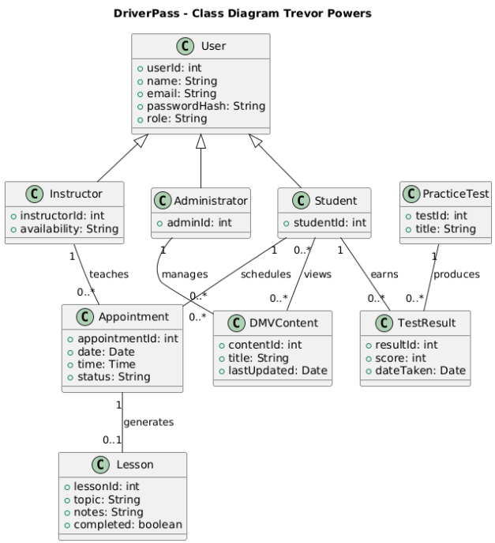

The class diagram shows the overall structure of the DriverPass system and the main components that the system is based on. The main components are based on a general user class that contains basic information such as name, email, and password. This general user class is then extended to create other user roles such as Student, Instructor, and Administrator. The system also contains classes such as Appointments, Lessons, Practice Tests, Test Results, and DMV Content. These classes contain important information such as lesson times and test results. This way of structuring the system makes it easier to manage and keep the data structured.

Technical Requirements

The DriverPass website will be designed as an online application, making it accessible to all users, including students, teachers, and administrators, through any internet-connected device. This is because an online application does not require any special software to be installed on the computer, making it accessible through devices such as laptops, tablets, and even smartphones. The application will be hosted on a cloud server, making it possible to serve multiple users simultaneously. This is important because the DriverPass business is expected to grow, and the applicants will be able to handle the increased demand.

From a technical standpoint, the DriverPass application will be designed as a secure online application with a database where all user information will be stored. The application will be able to support different types of modern web browsers, such as Google Chrome and Microsoft Edge. The application will be made secure using secure authentication methods for users. In terms of planning, different tools, such as Lucid Chart, will be employed to create the application. The infrastructure will be designed with a centralized database where all user information will be stored. The application will be hosted on a cloud server, making it possible to serve multiple users simultaneously. This will ensure that the application is able to handle increased demand when the business grows. The infrastructure will also be designed with proper backup systems to ensure that important user information is handled properly.

